Big Data Analytics and Visualization Using AWS and PySpark
Noopur Shekhar Divekar

Objective
The primary objective of this project was to design and implement a scalable, end-to-end Big Data analytics pipeline using Amazon Web Services (AWS) and PySpark. The project aimed to process large-scale datasets efficiently in a distributed cloud environment to derive actionable business insights. Furthermore, it incorporates automated machine learning via AWS SageMaker to predict customer churn and utilizes Power BI to visualize key metrics, ensuring a comprehensive analysis from raw data to business insights.

Project Workflow
- Dataset Selection
The Churn Modelling dataset contains 10,000 records of bank customers, designed for analyzing customer attrition. It consists of 14 columns capturing demographic, financial, and behavioral attributes.
Unique identifiers include CustomerId and Surname, while core demographic data covers Geography, Gender, and Age. Financial health is represented by CreditScore, Balance, and EstimatedSalary, alongside behavioral metrics such as Tenure, NumOfProducts, HasCrCard, and IsActiveMember.
The target variable, Exited, is binary (1 for churned, 0 for retained), making the dataset ideal for classification tasks like churn prediction. The combination of numerical and categorical data supports robust predictive modeling and customer segmentation, enabling banks to identify at-risk clients and develop data-driven retention strategies.
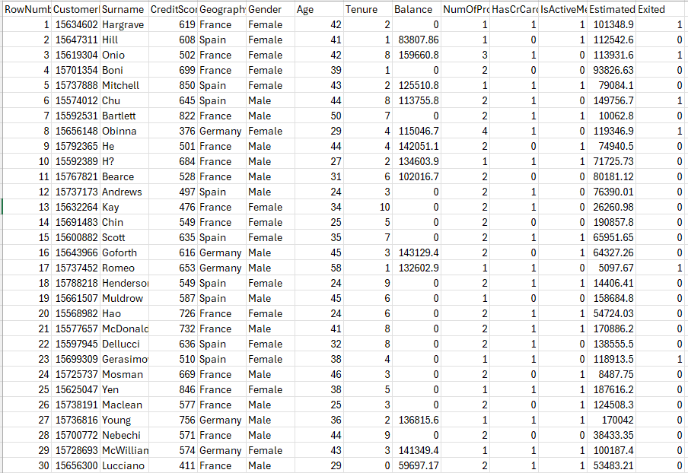

Pipeline Workflow
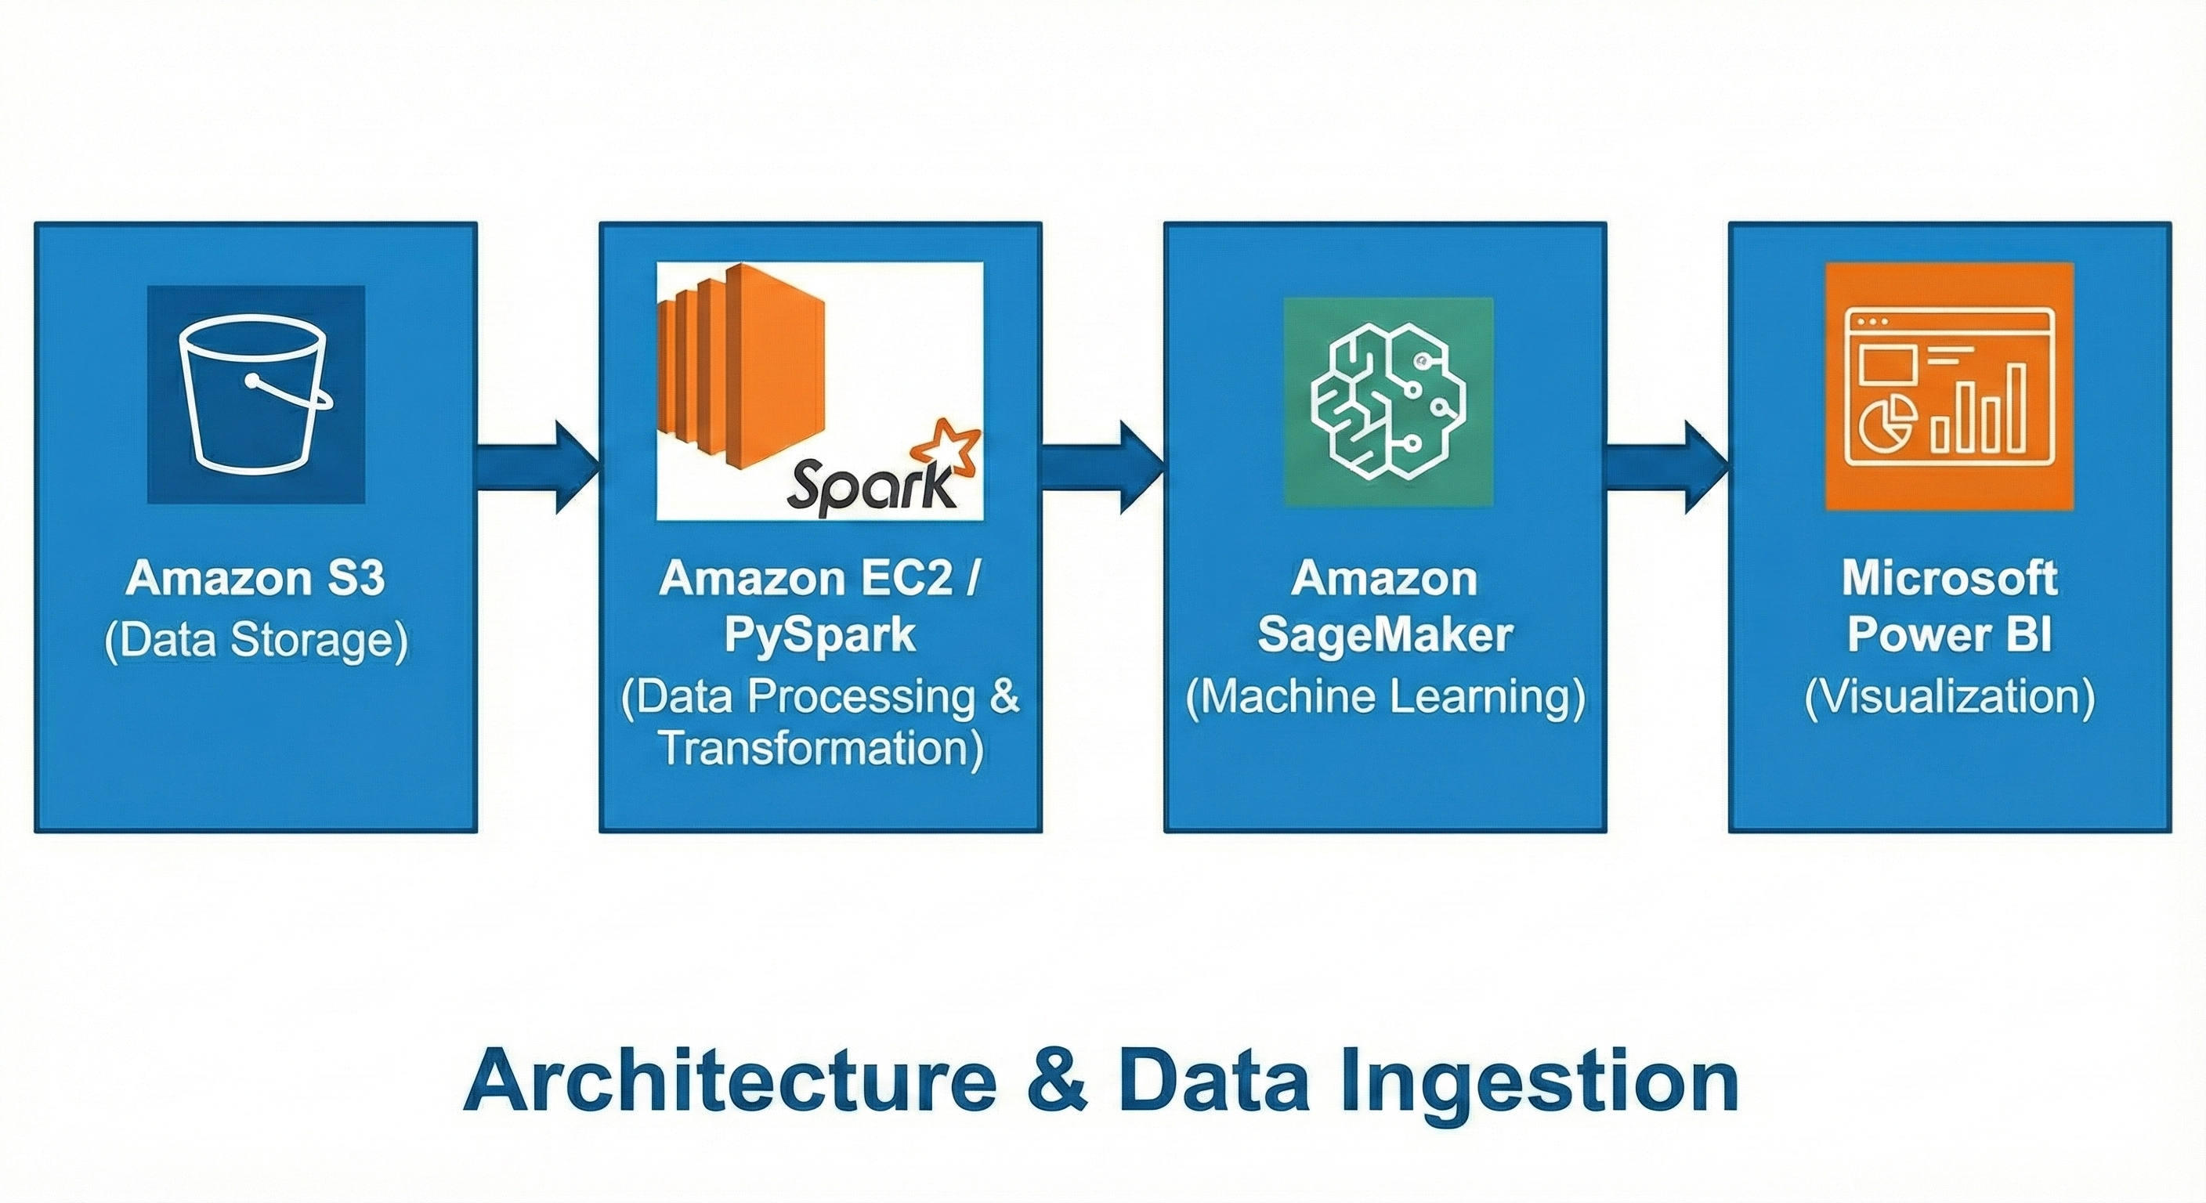

Environment Setup

AWS S3 for Data Storage
  - Step 1: Create an S3 bucket to store both raw and processed data.
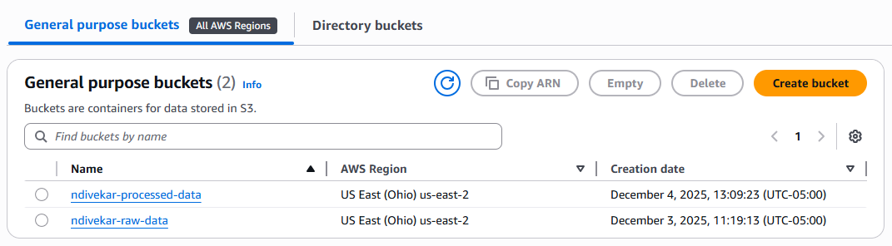
  - Step 2: Upload the raw dataset to the S3 bucket.
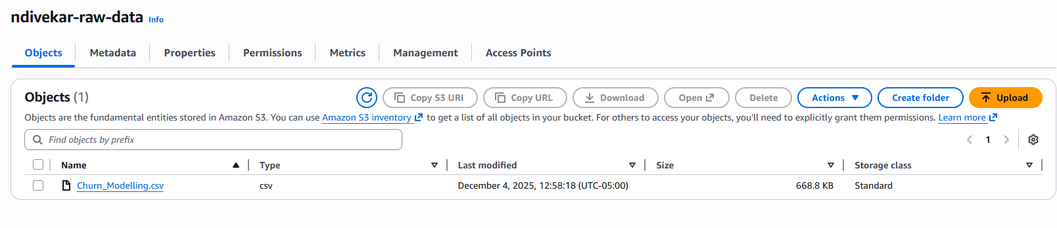

Linux Environment with PySpark
  - Step 1: Set up a Linux-based environment using an AWS EC2 instance.
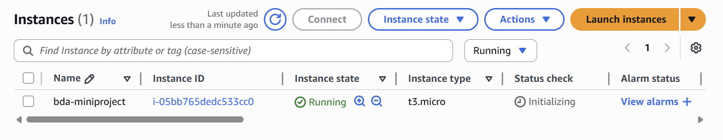
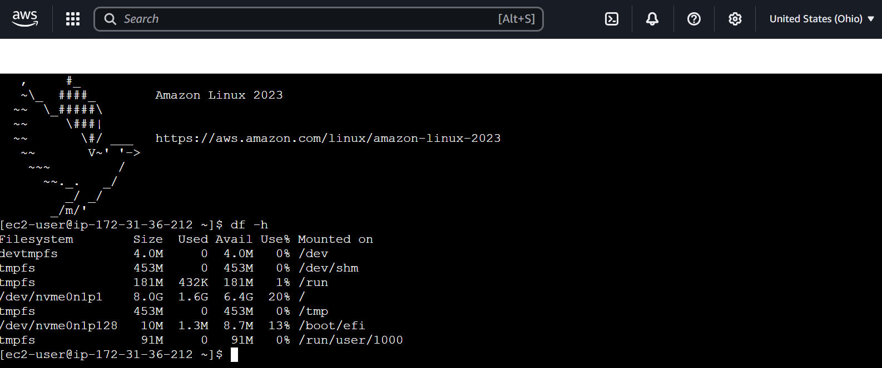

  - Step 2: Install PySpark for distributed data processing.
Commands I ran to -
- Update the System:
sudo yum update -y

- Install Python, Pip, and Java (Required for Spark)
sudo yum install python3-pip java-17-amazon-corretto -y

- Download Apache Spark: Download Apache Spark and is extracted using the following commands. The spark version installed is 4.0.1
wget https://dlcdn.apache.org/spark/spark-4.0.1/spark-4.0.1-bin-hadoop3.tgz
tar xvzf spark-4.0.1-bin-hadoop3.tgz

- Move the Spark Directory: Move the extracted spark directory to a more appropriate location.
The command is: sudo mv spark-4.0.1-bin-hadoop3 /opt/spark

- Set the Evironment Variables: The SPARK_HOME environment variable was set to the directory where the Spark is extracted. This allows Spark to be accessed from anywhere in the terminal. Do the following changes in the ~/.bashrc:
export SPARK_HOME=/opt/spark
export PATH=$SPARK_HOME/bin:$PATH
export JAVA_HOME=/usr/lib/jvm/java-1.8.0-amazon-corretto.x86_64/jre
export PATH=$JAVA_HOME/bin:$PATH

- Install Spark using pip3:
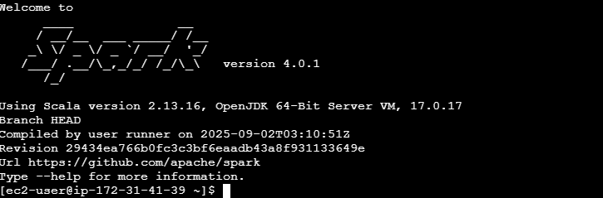

  - Step 3: Configure AWS CLI to interact with S3 buckets.
Successfully installed and configured the AWS CLI on EC2 instance to connect with the S3 buckets. To manage and access S3 buckets, such as ndivekar-raw-data, directly from the command line on EC2 instance.

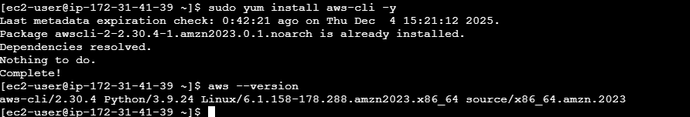

The image below confirms that the connection between the EC2 instance and S3 has been successfully established. It displays a list of S3 buckets, verifying that the instance can interact with S3 using the provided credentials and configurations. This indicates that the setup for accessing S3 from the EC2 instance, whether via the AWS CLI or Boto3, is functioning as expected.

Data Pipeline Tasks

Task 1: Data Ingestion from S3
  - Objective: Pull raw data from S3 into the PySpark environment.

Steps:
- Use AWS CLI or PySpark’s built-in S3 support to load the dataset directly.
- Confirm successful ingestion by inspecting the dataset.

This Python script explains how to retrieve a CSV file from an AWS S3 bucket and load it into PySpark for data processing. Boto3 connects to S3, downloads Churn_Modelling.csv from the ndivekar-raw-data bucket, and saves it locally. A PySpark session is set up for distributed data processing. The script then reads the local CSV file into a PySpark Data Frame, which includes headers and automatically infers structure. Finally, the schema for the dataset is printed to ensure its structure.
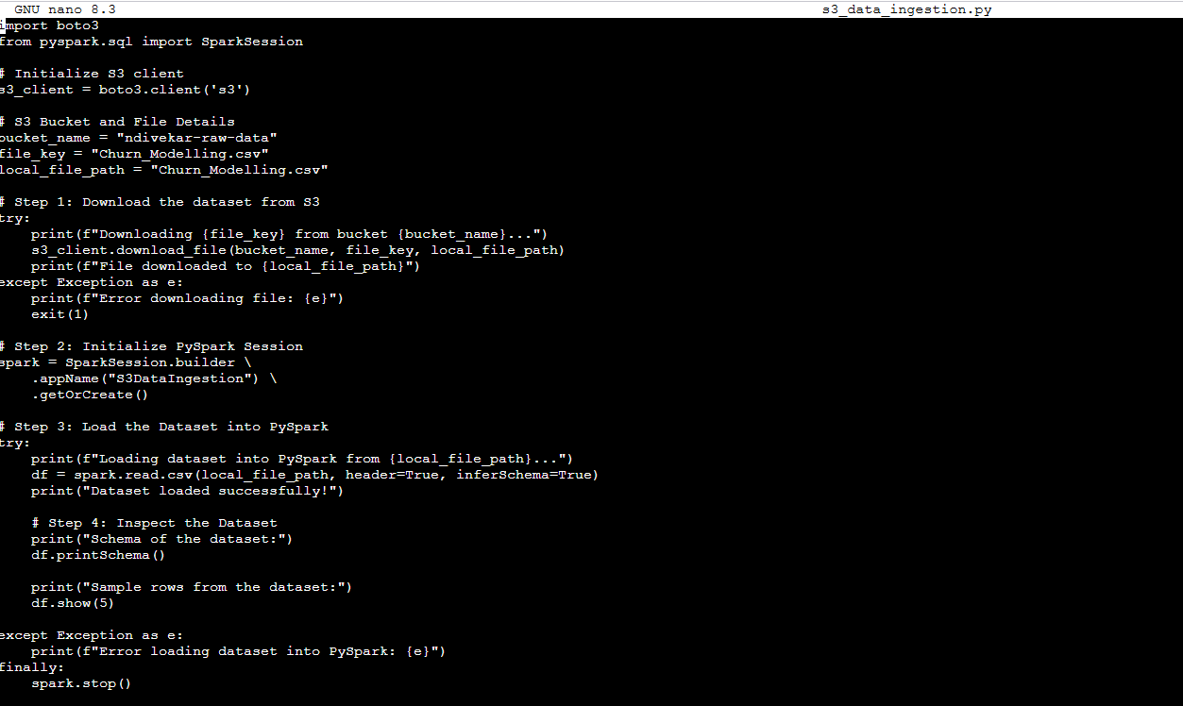
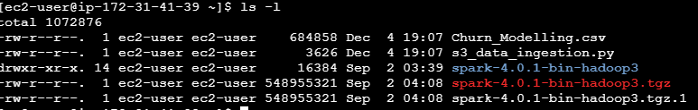

The image below shows the output from the s3_data_ingestion.py file. It outputs the schema of the dataset and it also displays the first 5 rows of the dataset.
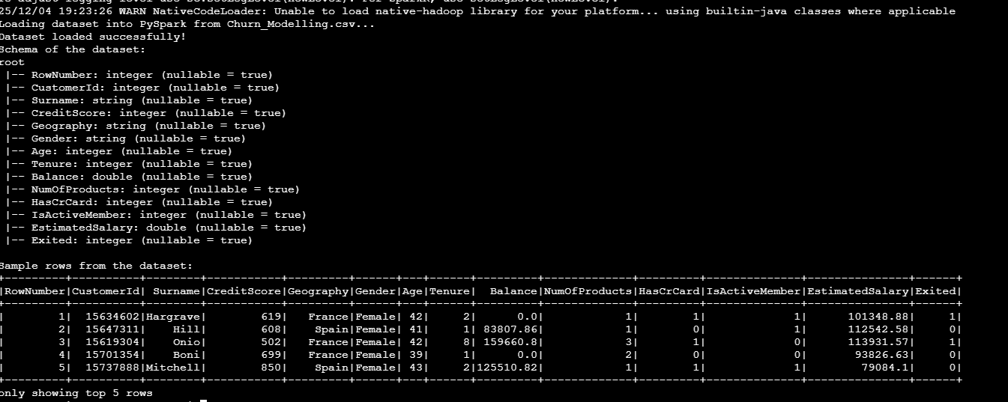

Task 2: Data Processing with PySpark
Checking for missing values:
To perform transformation and aggregation, first we need to check if the dataset has any missing values.
This PySpark software detects missing values in the dataset. It begins by initializing a Spark Session and loading a CSV file into a PySpark DataFrame using schema inference. After showing the schema, it discovers missing values column by column by producing a binary column for each field, where null values are represented as 1 and non-values as 0. This script combines these binary columns using the sun function to compute the total count of null values in each column.
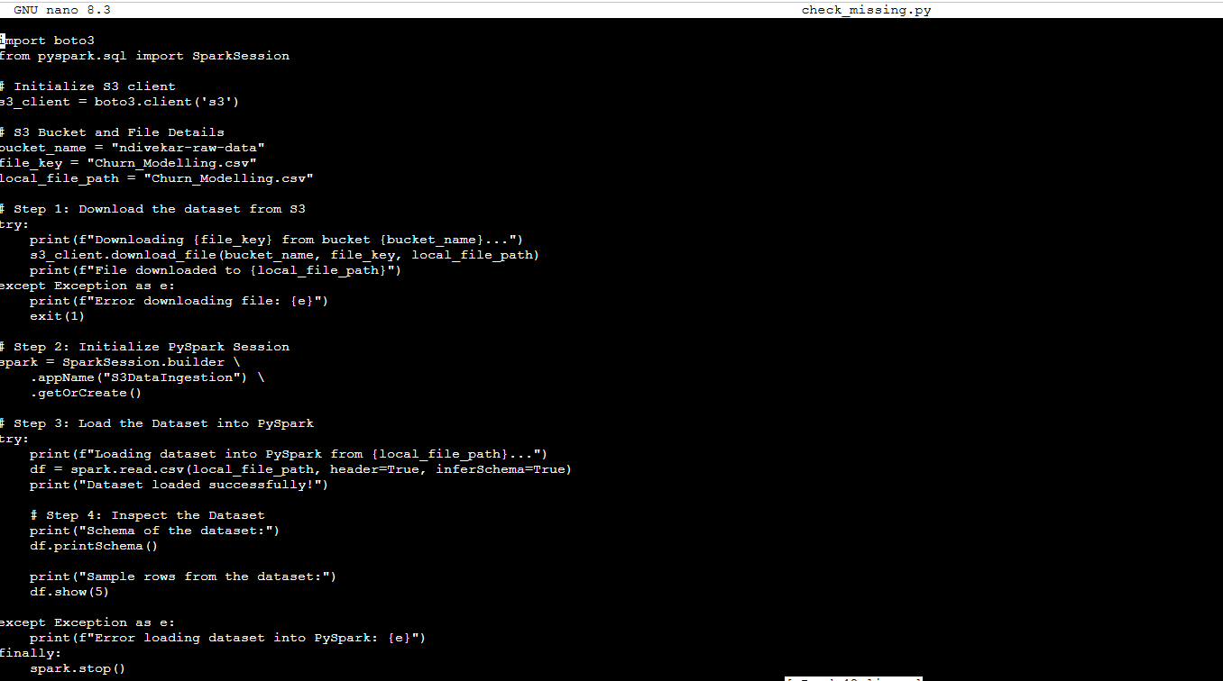
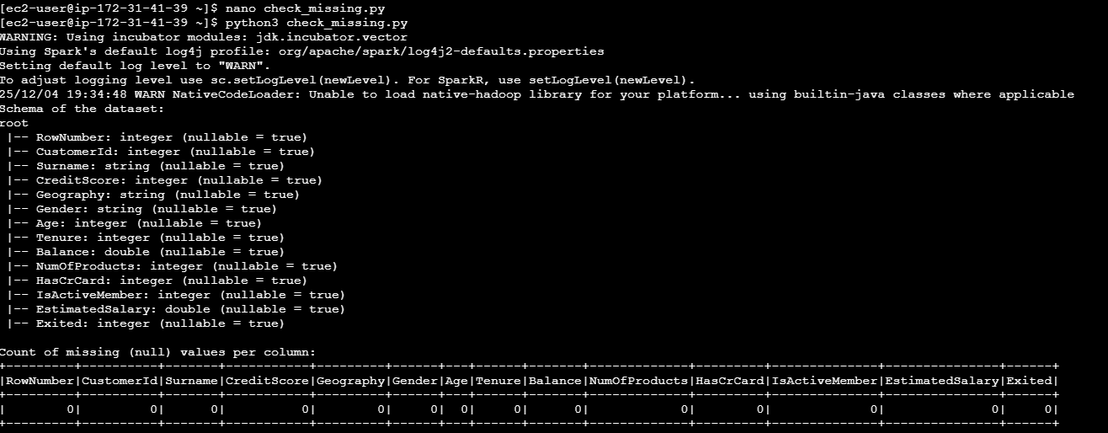

- Data Transformation: Create at least 2 new columns (e.g., Year, Month) to aid in analysis.
Encoding Categorical Features:
This is the encode.py file, which encodes columns (Geography and Gender) in a dataset with StringIndexer. It looks for existing encoded columns and eliminates them to avoid conflicts. The changed dataset is saved to a new CSV file, and a sample of the data is presented.
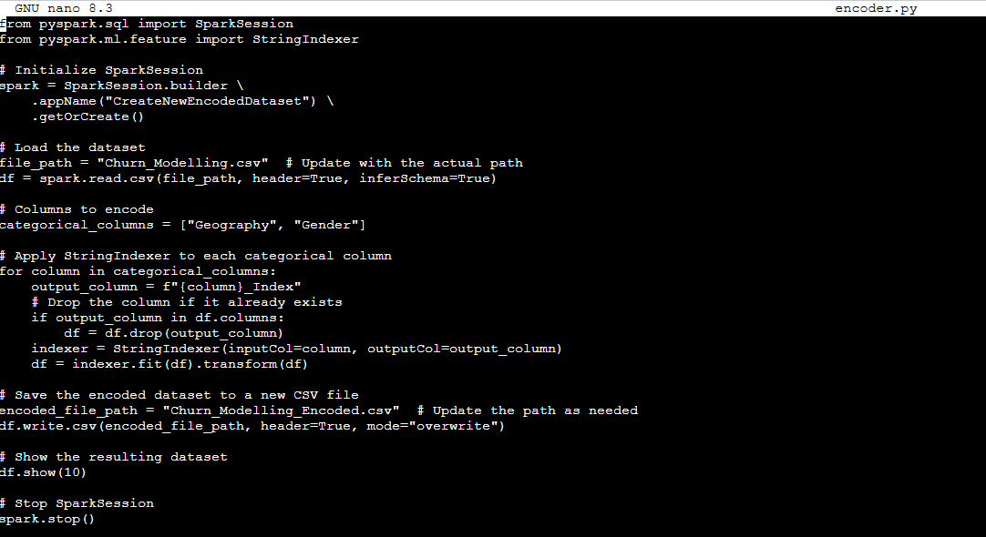
Output:
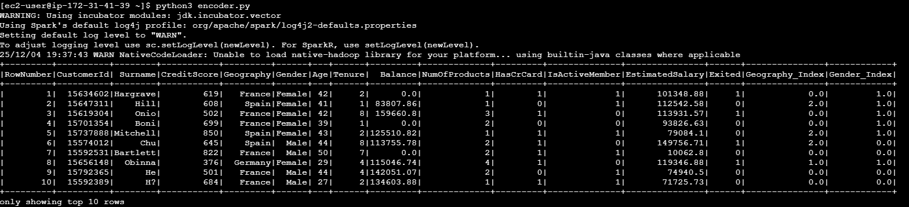

Normalizing features:
This is the normalize.py code, which normalizes the Balance and EstimatedSalary columns with MinMaxScaler. It converts these columns into a feature vector, scales them from 0 to 1, and extracts the normalized values into a new column.
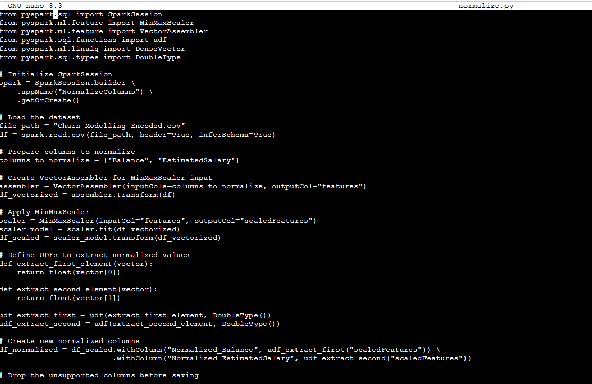
Output:
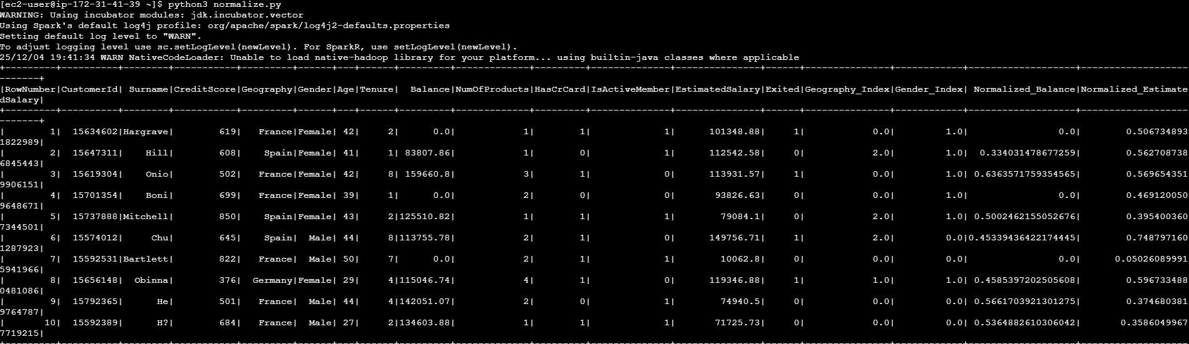

- Data Aggregation:
Total Balance by Geography:
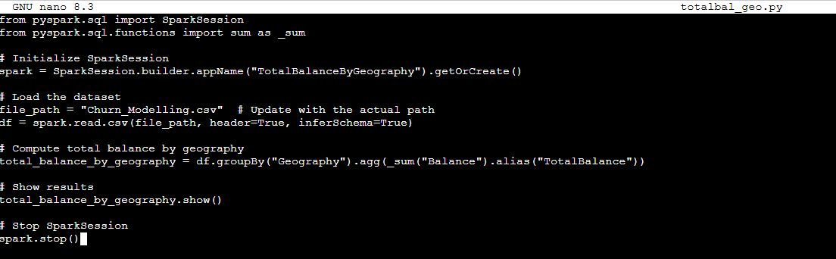
This PySpark code calculates the dataset's total bank balance, organized by geography. It creates a SparkSession, loads a CSV file, and conducts a group-by operation on the "geography" column before summing the "Balance" column. The results are displayed, and SparkSession is terminated following the execution.
Output:
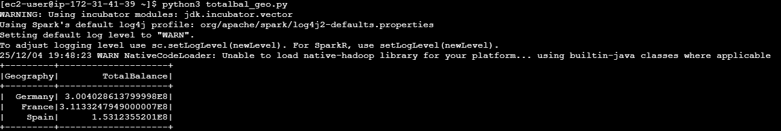

Average Salary by Geography:
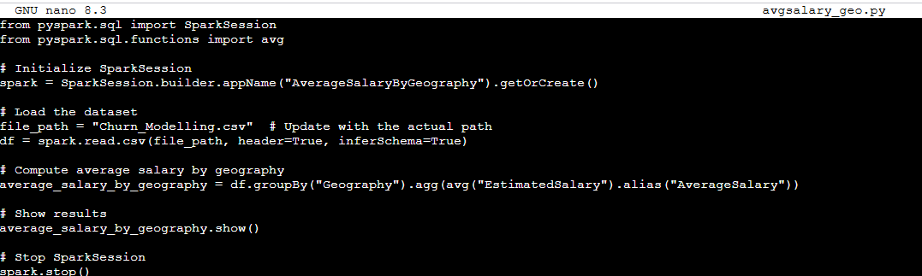
This PySpark code computes the average expected salary for each geography in the dataset. It creates a SparkSession, loads a CSV file, and does a group-by operation on the "Geography" column to calculate the average of the "EstimatedSalary" column. The results are displayed, and the SparkSession terminates.
Output:
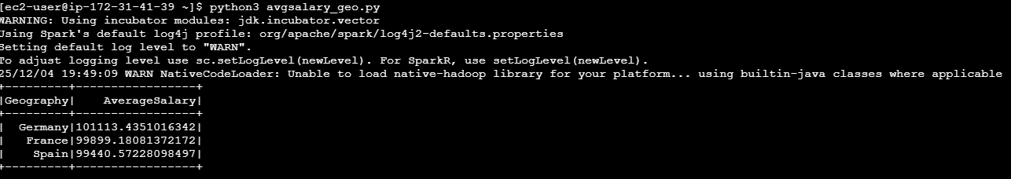

Average Balance by Tenure:
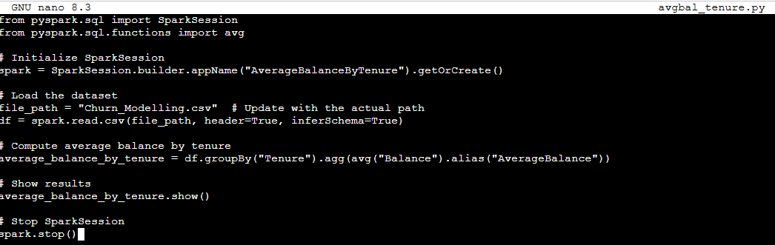
This PySpark code calculates the average bank balance based on customer tenure from the dataset. It creates a SparkSession, loads a CSV file, and executes a group-by operation on the "Tenure" column to calculate the average of the "Balance" column. The results are displayed, and the SparkSession terminates.
Output:
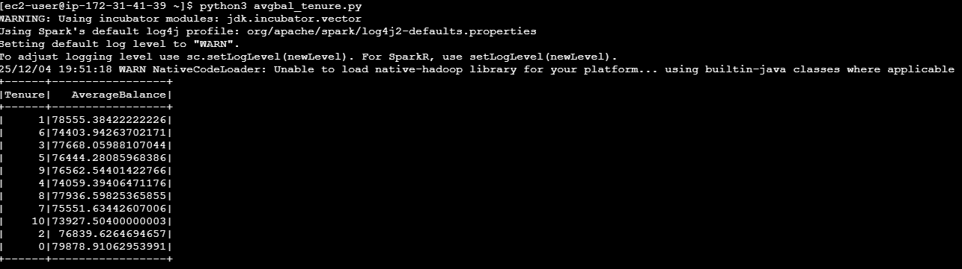

Top 10 Customers by Balance:
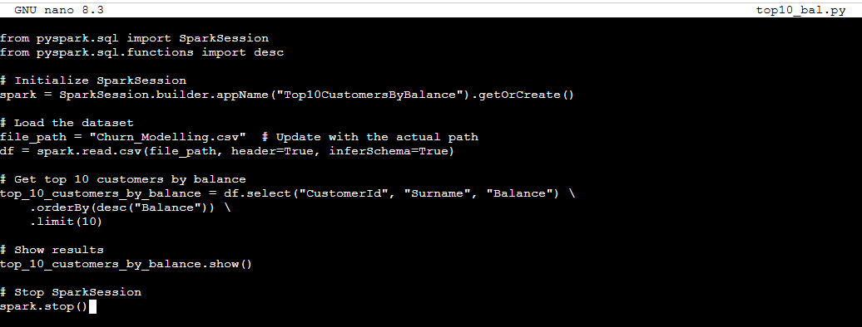
This PySpark code determines the top ten customers with the highest bank balances. It launches a SparkSession, loads a CSV file, selects key columns ("CustomerId", "Surname", and "Balance"), and arranges the data in descending order by "Balance". The top ten results are shown, then the SparkSession terminates.
Output:
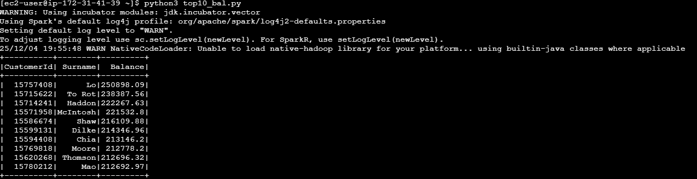

Total Active Customers by Region:
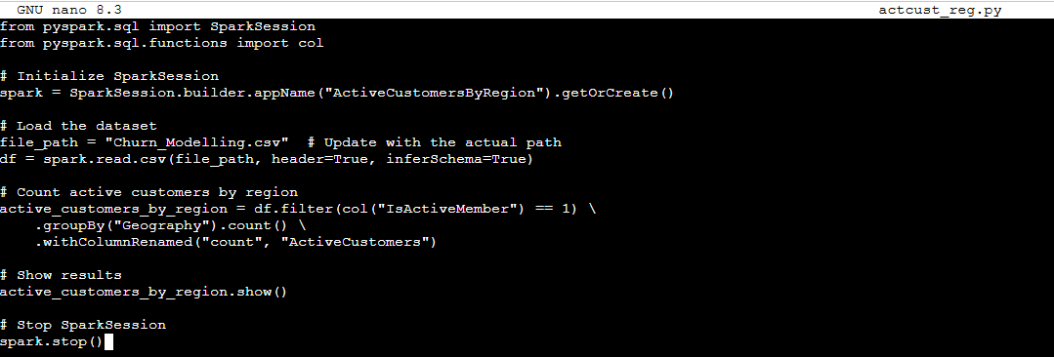
This PySpark code counts the number of active customers grouped by "Geography". It initiates a SparkSession, loads a CSV file, filters rows where "IsActiveMember" equals 1, groups the data by "Geography", and counts active customers in each region. The results are shown, and SparkSession is terminated.
Output:
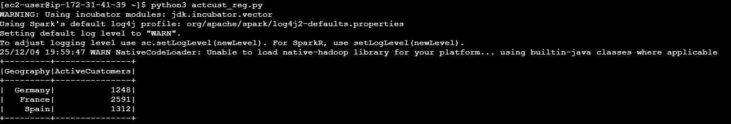

Task 3: Store Processed Data Back to S3
  - Objective: Save the processed and aggregated data to a new S3 bucket or folder.

Steps:
- Export data in CSV or Parquet format.
- Upload the processed data to a designated S3 location for easy access. (Generating new CSV, downloading it and uploading to S3 bucket is fine).
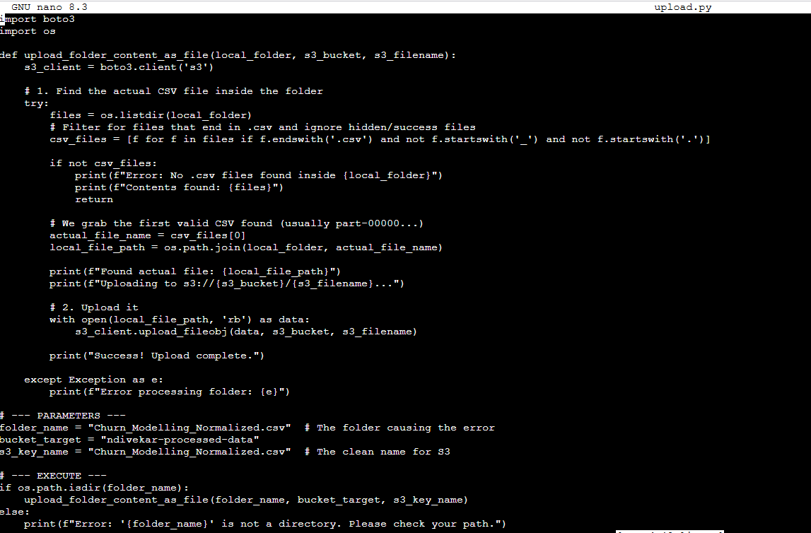
This Python script uploads all files in a given local directory to an Amazon S3 bucket. It uses Boto3 to setup an S3 client, then traverses the local directory and uploads each file to the bucket specified by the file name.

Output:
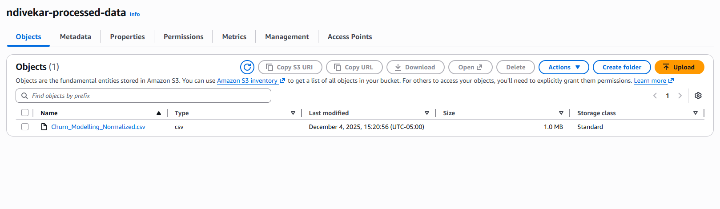

Task 4: Data Analysis Using Spark SQL

Objective: Use SQL to derive insights
Queries:
- Identify regions with highest total account balance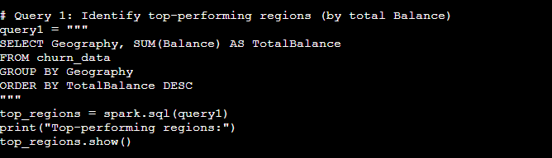
Output:
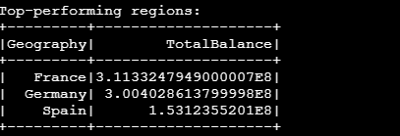

- Analyze monthly revenue growth based on the Tenure Field, which acts as a proxy for months.
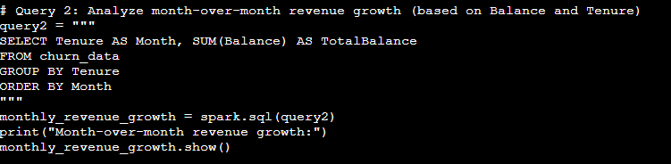
Output:
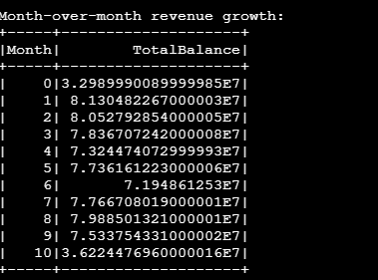

- Determines the most popular product categories based on the count of customers in each category (NumofProducts).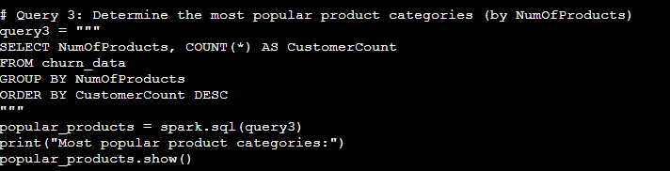
Output:
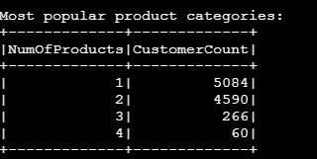

- Calculates the percentage of active customers (IsActiveMember) in each region.
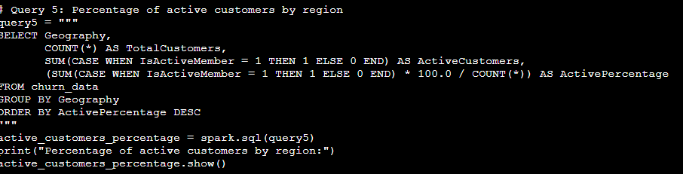
Output:
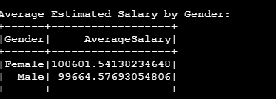

- Computes the average salary for male and female customers.
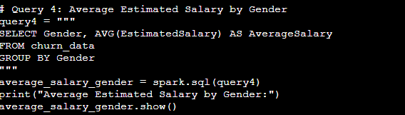
Output:
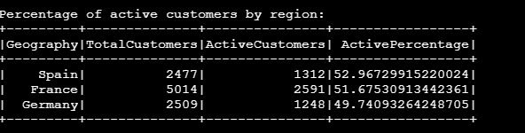

Task 5: Machine Learning with AWS SageMaker Autopilot
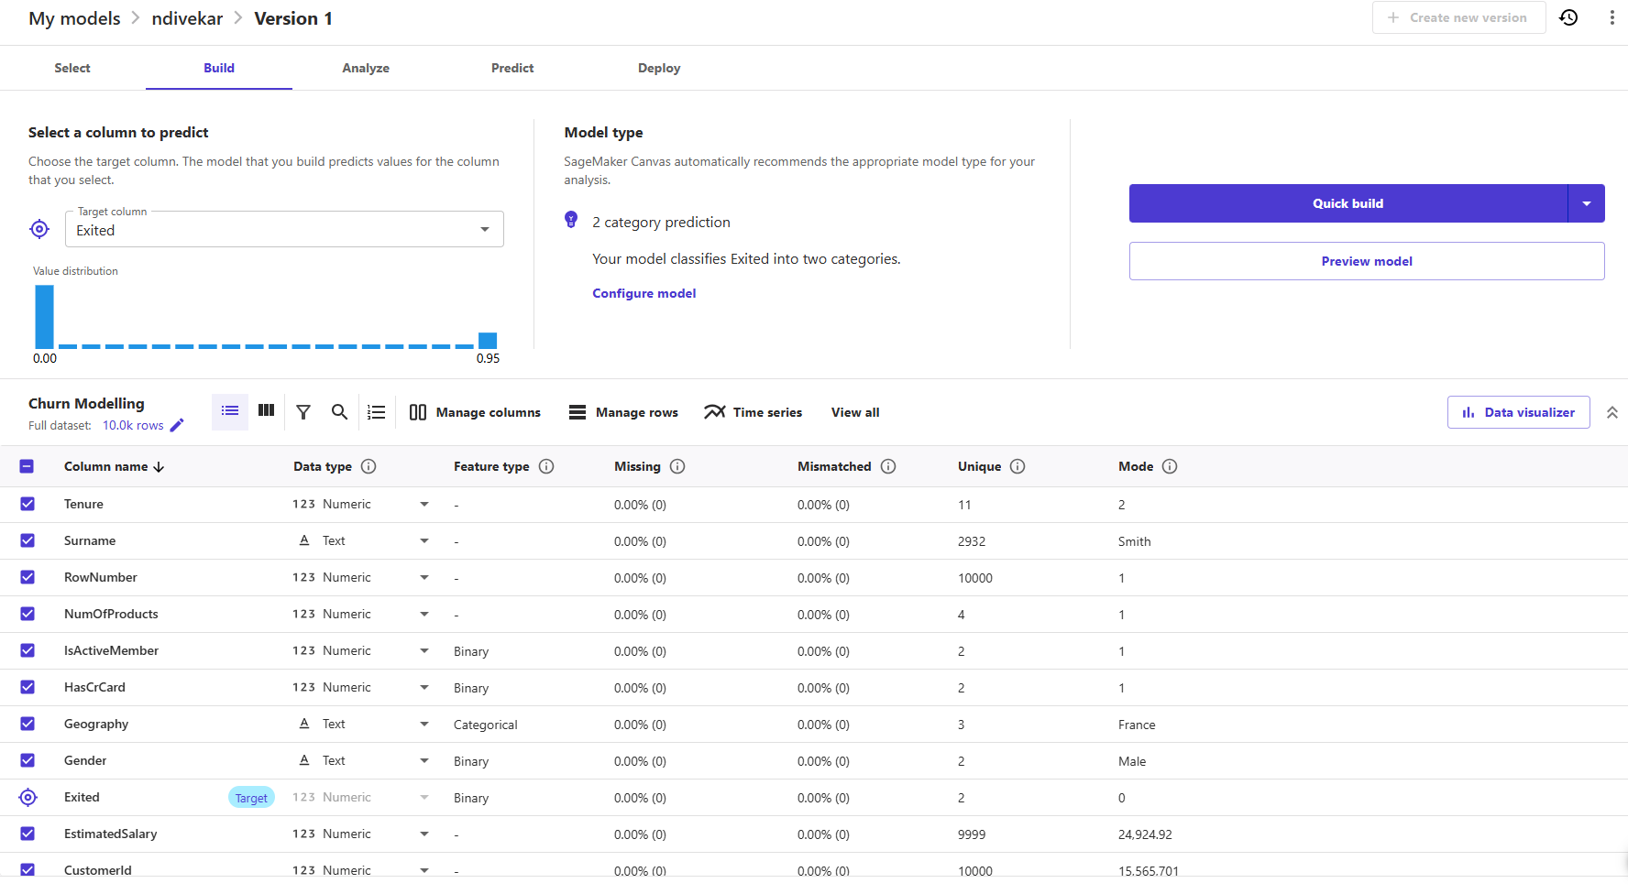
Let's break down what we're seeing in that Amazon SageMaker Canvas image for the churn model. It's a pretty straightforward setup:
- The Goal (Target Column): The primary objective is predicting customer turnover, or churn. That's why the “Exited” column is selected as the target. The model is being trained to figure out if a customer will leave or stick around.
- The Model Recommendation: SageMaker is smart; it automatically suggested a “2-category prediction.” This just means it knows we're dealing with a simple yes/no question (binary classification): Will the customer exit, or won't they?
- The Data: We're working with a solid dataset that has 10,000 customer records and 14 data columns (features). A great sign is that the interface is showing 0% missing values across the board. We can also peek at other helpful stats like how many unique values and the most common value (the mode) for each column.
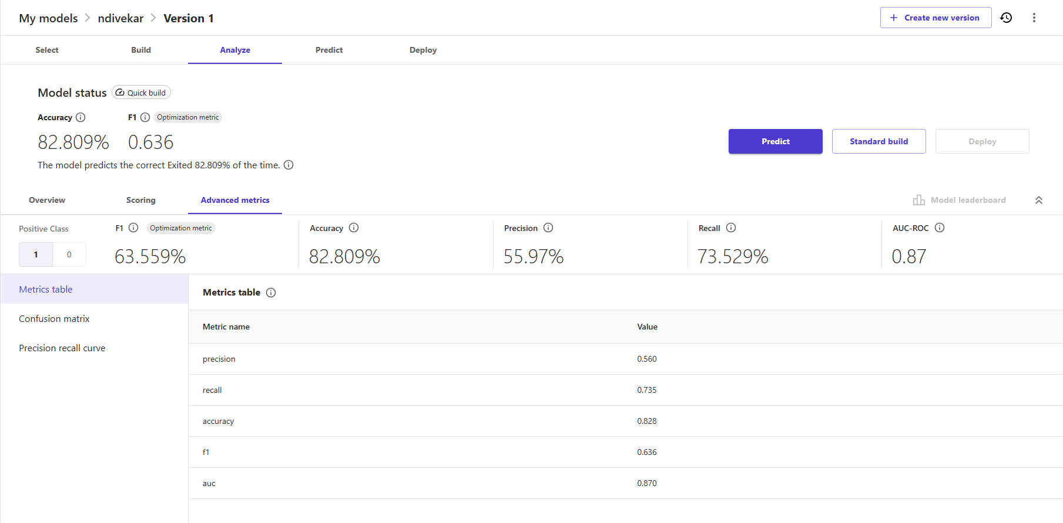
The analysis tab in Amazon SageMaker Canvas confirms the machine learning model has completed a Quick Build, yielding initial performance statistics. The overall Accuracy of the model registered at 82.809%, indicating that the predictive capability correctly classified the “Exited” target column approximately 82.8% of the time.
The optimization metric used for balancing classification quality, the F1 Score, achieved a value of 0.636. A deeper examination of the advanced metrics reveals a Precision of 55.97%, which measures the accuracy of true positive predictions, and a Recall of 73.529%, which measures the percentage of true positives that the model successfully captured. Furthermore, the Area Under the Curve (AUC-ROC) value of 0.87 indicates a strong capacity for overall classification performance.
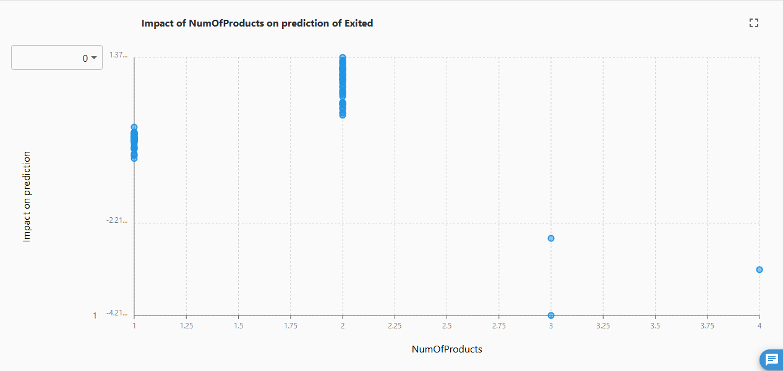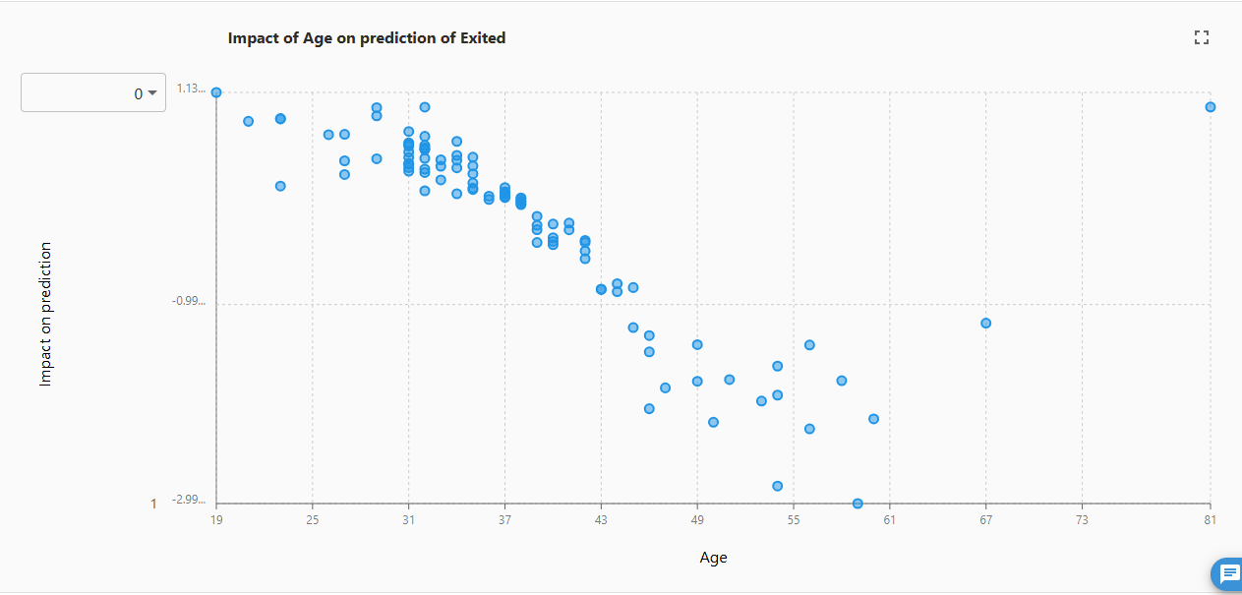
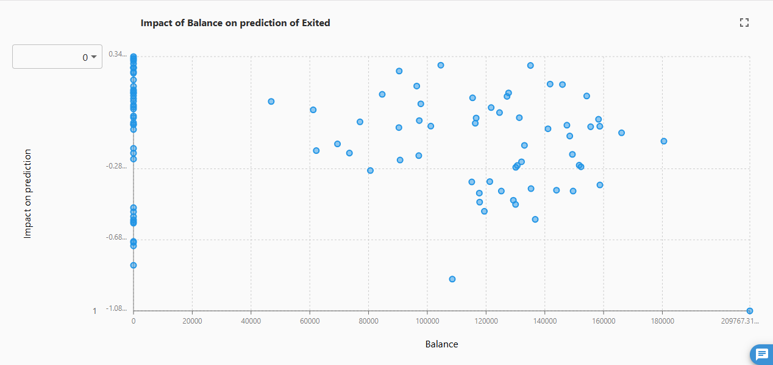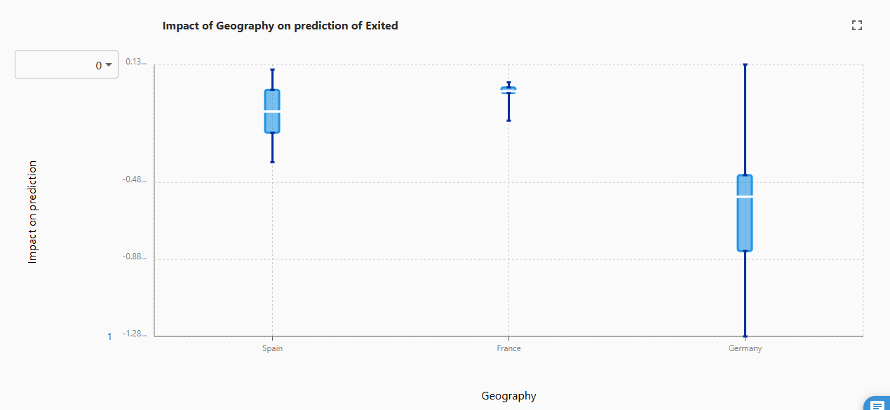

The model's performance on the sample dataset is visually represented through a Sankey chart, which maps the predicted versus actual outcomes. The chart indicates that the majority of correct classifications are concentrated in Class 0 (non-exited) outcomes, depicted by the blue flows, while all incorrect predictions are distinctively represented by the pink flows. Out of 2,001 total predictions evaluated in this sample, 1,593 were correct classifications specifically for Class 0.
The corresponding Model Accuracy Insights provide specific performance metrics for this majority class. The model demonstrates high Precision for Class 0, being correct 92.628% of the time when it forecasts a non-exited outcome. Furthermore, the Recall for Class 0 is 85.185%, indicating that the model successfully identified 85.185% of all actual Class 0 values present within the dataset.

A Sankey chart illustrates the flow of predicted versus actual outcomes:
- Most correct predictions belong to class 0 (non-exited), represented in blue.
- Incorrect predictions are highlighted in pink.
- Total predictions: 2,001, with 1,593 correct predictions for class 0.
Model Accuracy Insights:
- When the model predicts class 0, it is correct 92.628% of the time.
- Among all actual class-0 cases, the model predicts class 0 with 85.185% accuracy.
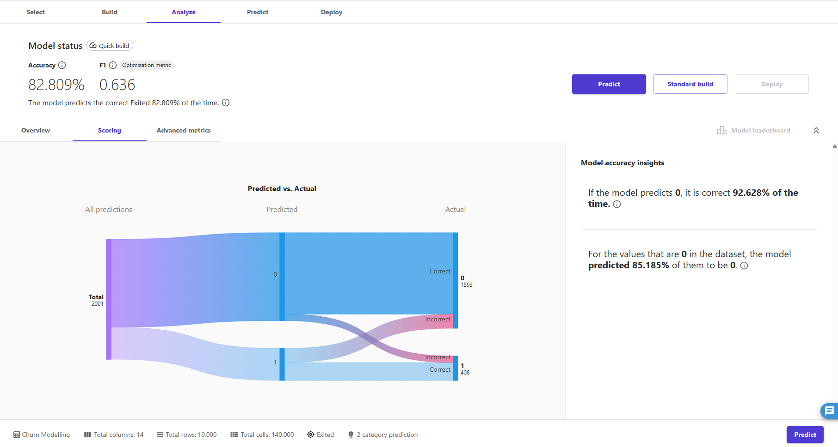

Visualization
  - This visualization shows a pie chart titled “Sum of Exited by Isactivemember”. It visualizes the sum if customer exits grouped by their active membership status. The chart contains two segments:

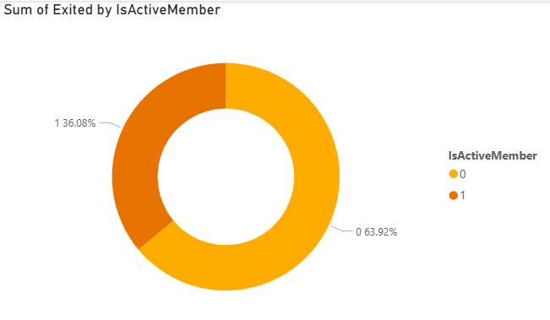
1: Represents by an orange section, it corresponds to active members.
0: Represents by a yellow section, it corresponds to inactive members.

  - This visualization displays a pie chart “Sum of balance by NumofProducts”. The chart represents the total balance, 764.86M, distributed across customers grouped by the number of products they use.
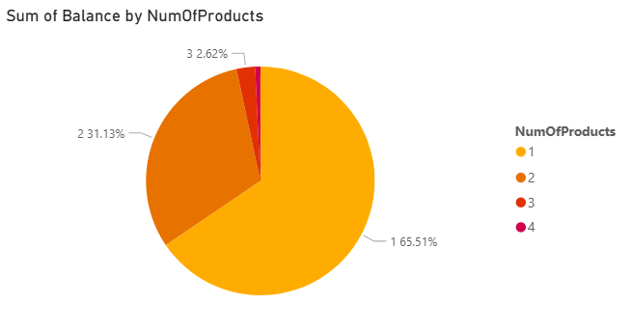

  - This visualization displays a bar chart titled “Count of records by Gender”. It visually represents the count of records categorized by gender into two groups: Male and Female.
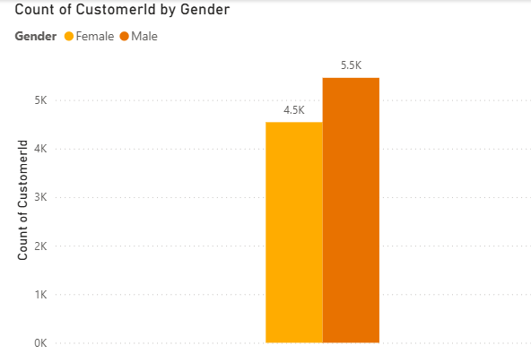

    - The Male category has a taller bar, indicating a count close to 5.5k records.
    - The Female category has a shorter bar, showing a count slightly above 4.5K records.

  - This image shows a bar chart titled “Sum of Exited by Geography”. It visualizes the total number of customers exits across three geographic regions: Germany, France, and Spain.
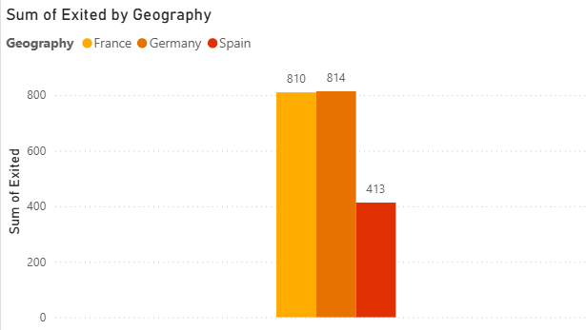

    - Germany and France have the highest count of exits, with their bars reaching close to 800.
    - Spain has significantly fewer exits, with the bar slightly above 400.

Live link to the visualizations: https://app.powerbi.com/view?r=eyJrIjoiNjNlYTI3NzMtYzk4Yy00ZWE4LWI3Y2YtNDMxMWEzNmViN2NjIiwidCI6IjExMTNiZTM0LWFlZDEtNGQwMC1hYjRiLWNkZDAyNTEwYmU5MSIsImMiOjN9

